Optimizers in Deep Learning
- An optimizer is an algorithm used to update model weights in order to minimize the loss function.
- Optimizer decides how and how fast the neural network learns.
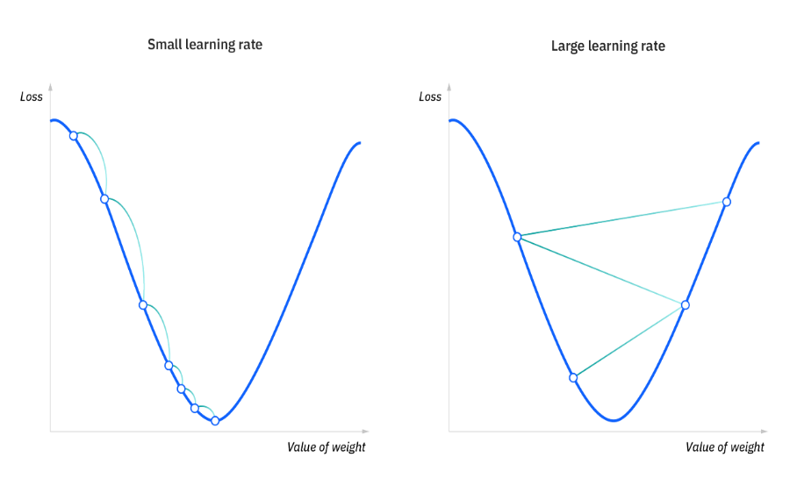

Training flow:
Input → Forward Pass → Loss
↓
Backpropagation
↓
Optimizer updates weights

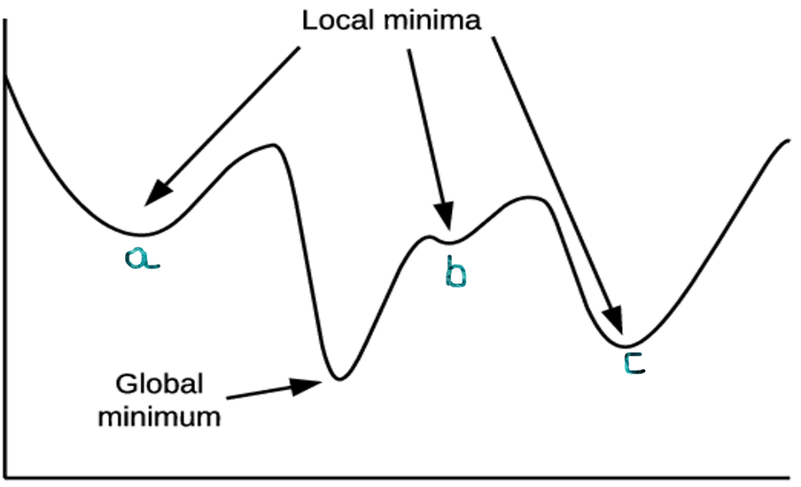
Why Optimizers are Needed?

- Loss function only measures error
- Optimizer reduces that error
- Helps in:
  - Faster convergence
  - Avoiding local minima
  - Stable learning

Gradient Descent
Weight Update Formula:
$$w=w-η\frac{∂L}{∂w}$$
Where:
- $η$= Learning Rate
- $\frac{∂L}{∂w}$= Gradient

Types of Gradient Descent
Batch Gradient Descent
- Uses entire dataset
- Slow for large data
- Stable but expensive
Stochastic Gradient Descent (SGD)
- Uses one sample at a time
- Fast but noisy
- Can escape local minima
Mini-Batch Gradient Descent
- Uses small batches (32, 64)
- Most commonly used
- Balance of speed + stability

Popular Optimizers in Deep Learning

1. SGD (Stochastic Gradient Descent)
- Stochastic Gradient Descent (SGD) is an optimization algorithm used to update model weights using only ONE training example at a time.
- SGD learns step-by-step from each data point.

Formula:
$$w=w-η∇L(w)$$
Pros:
✔ Simple
✔ Memory efficient
Slow convergence
Best for:
- Simple neural networks
- When data is small

2. Momentum Optimizer
- Adds velocity to SGD
- Momentum Optimizer is an improvement over SGD that helps the model learn faster and more smoothly by remembering past gradients.
- Momentum optimizer uses previous gradients to decide the current weight update.

Why Do We Need Momentum?
Problem with SGD:
- Slow convergence
- Zig-zag movement in valleys
- Gets stuck in local minima
Momentum solves this by adding velocity.

Formula:
$$v_{t}=γv_{t-1}+η∇L(w) \\ w=w-v_{t}$$
Benefits:
✔ Faster convergence
✔ Reduces oscillations
Analogy:
Like a ball rolling downhill with speed

3. Adagrad (Adaptive Gradient)
- Learning rate adapts per parameter
- Adagrad (Adaptive Gradient) is an optimizer that automatically adjusts the learning rate for each parameter based on how frequently it is updated.
- Adagrad gives smaller learning rates to frequently updated parameters and larger learning rates to rarely updated parameters.

Why Adagrad Was Introduced?
Problem with SGD & Momentum:
- Same learning rate for all parameters
- Not good for sparse features
Adagrad solves this by adapting learning rates individually.

Core Idea
- Important features → updated many times → learning rate decreases
- Rare features → updated less → learning rate stays large
- Very useful in text / NLP data.

Pros:
✔ Good for sparse data
✔ Automatically adjusts learning rate
Learning rate becomes too small

4. RMSProp
- Fixes Adagrad’s learning rate problem
- RMSProp is an adaptive learning rate optimizer that fixes the main problem of Adagrad by using a moving average of squared gradients instead of accumulating them forever.
- RMSProp adjusts the learning rate using a running average of recent gradients.

Why RMSProp Was Introduced?
Problem with Adagrad:
- Learning rate keeps decreasing
- Eventually becomes almost zero

RMSProp:
- Forgets old gradients
- Keeps learning rate stable

Core Idea
- Look at recent gradients, not all past ones
- Big gradients → smaller step
- Small gradients → larger step
Very good for non-stationary problems (like RNNs).

Key Idea:
- Uses exponentially weighted average of gradients
Pros:
✔ Stable learning
✔ Good for RNNs

5. Adam (Most Popular ⭐)
👉 Combines:
- Momentum
- RMSProp
Formula idea:
- First moment (mean)
- Second moment (variance)

Pros:
✔ Fast convergence
✔ Works well for most problems
✔ Less tuning needed
Cons:
Sometimes worse generalization than SGD
Default choice in practice

6. AdamW
👉 Adam + Weight Decay
Benefits:
✔ Better regularization
✔ Used in Transformers (BERT, GPT)

Optimizer Comparison Table
Optimizer | Speed | Stability | Usage
SGD | Slow | Medium | Simple models
Momentum | Medium | High | CNNs
Adagrad | Medium | Low | Sparse data
RMSProp | Fast | High | RNNs
Adam | Very Fast | Very High | Default choice
AdamW | Very Fast | Very High | Transformers

Learning Rate – Most Important Hyperparameter
- Too high → divergence
- Too low → slow learning
Common values:
SGD → 0.01
Adam → 0.001

